How to audit encumbrances.
Please audit encumbrances at regular intervals. This will reduce the amount of duplicate or over budgeted encumbrances to free up funds in your budget.
NOTE: If at any time you do not see the desired option contact the help desk to request access.
Step 1 – Enter ULink and select the “Budget & Finance” Tab.
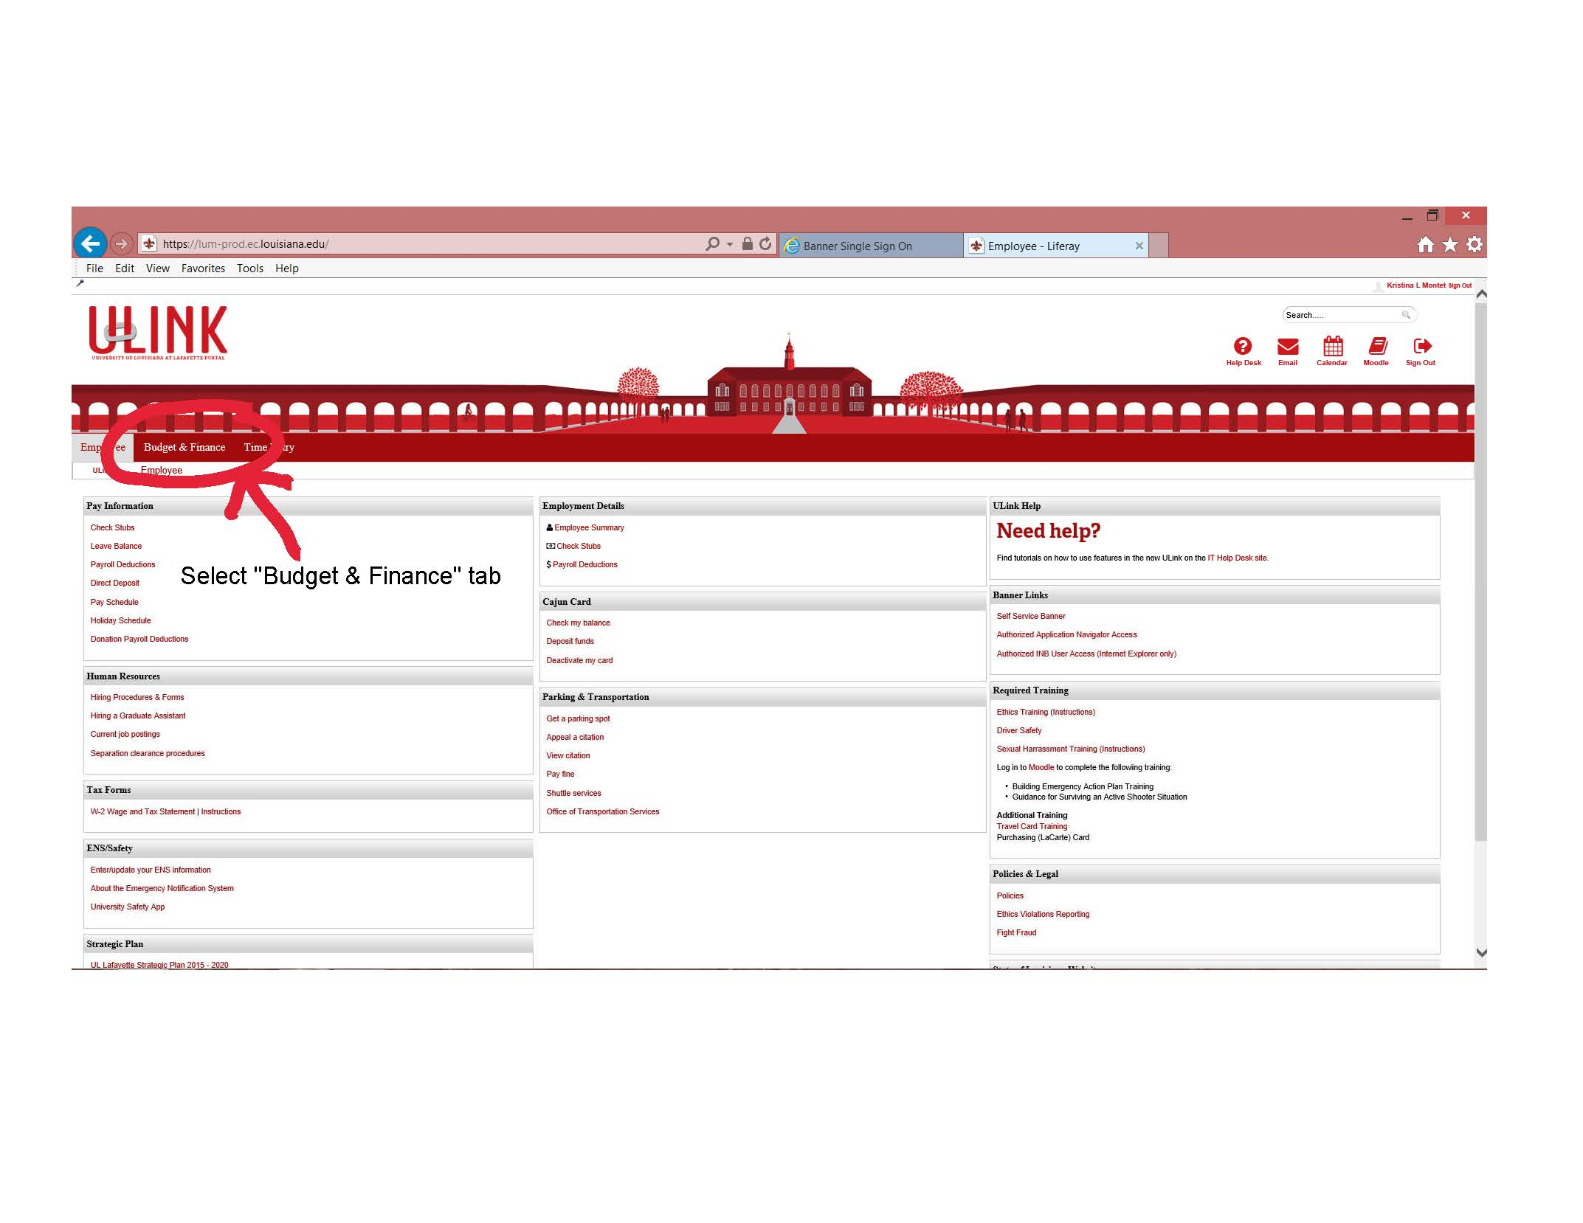
Step 2 – Under “Financial Resources” Select “Budget Query”
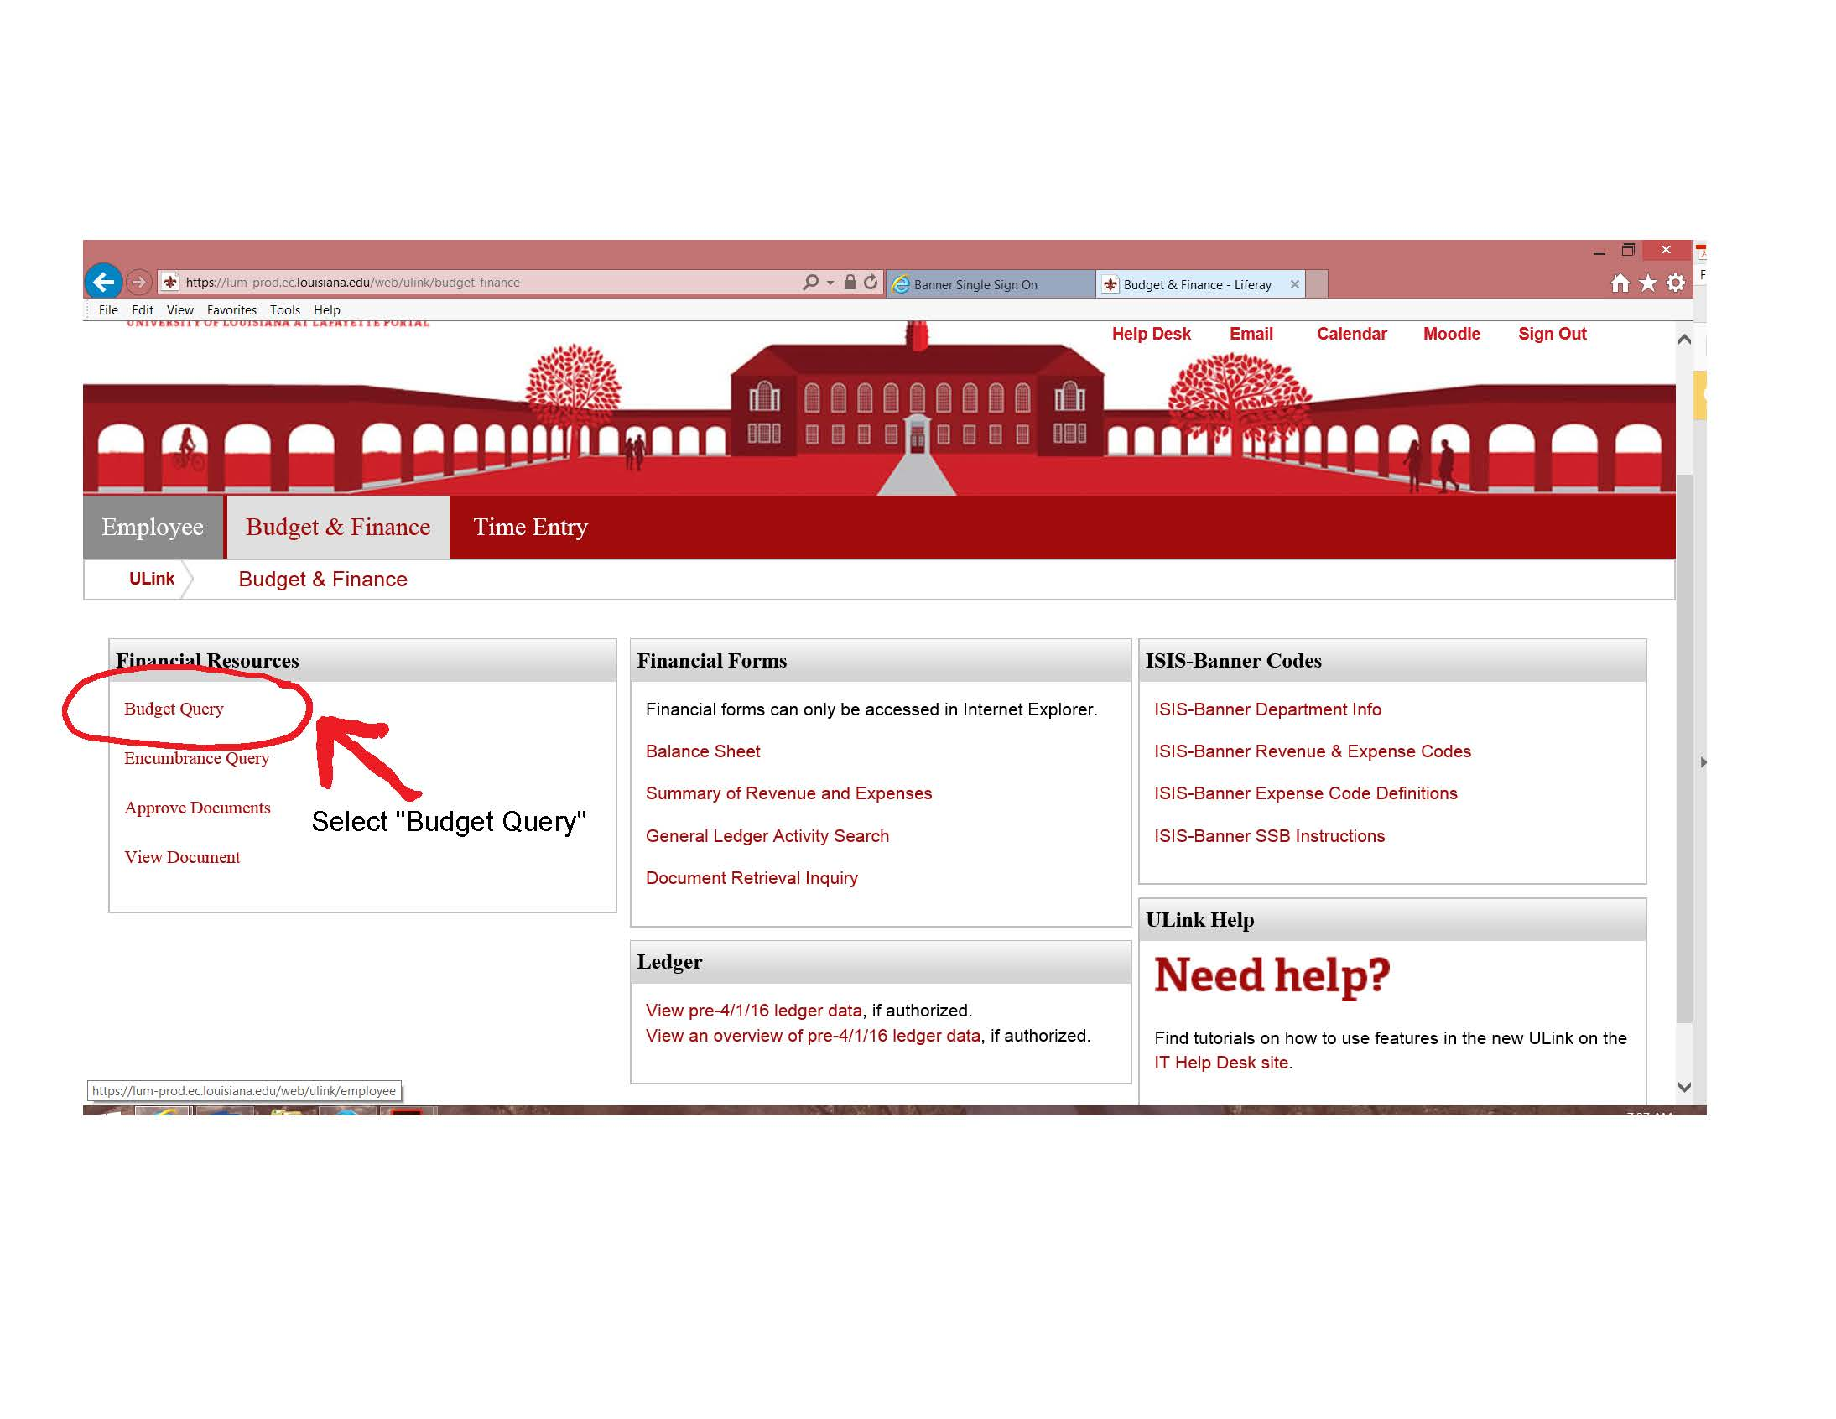
Step 3 – Select the type of query from the drop down menu. To be able to drill into encumbrance details you must select “Budget Status by Account”. (Quick Query will not allow you to view details.)
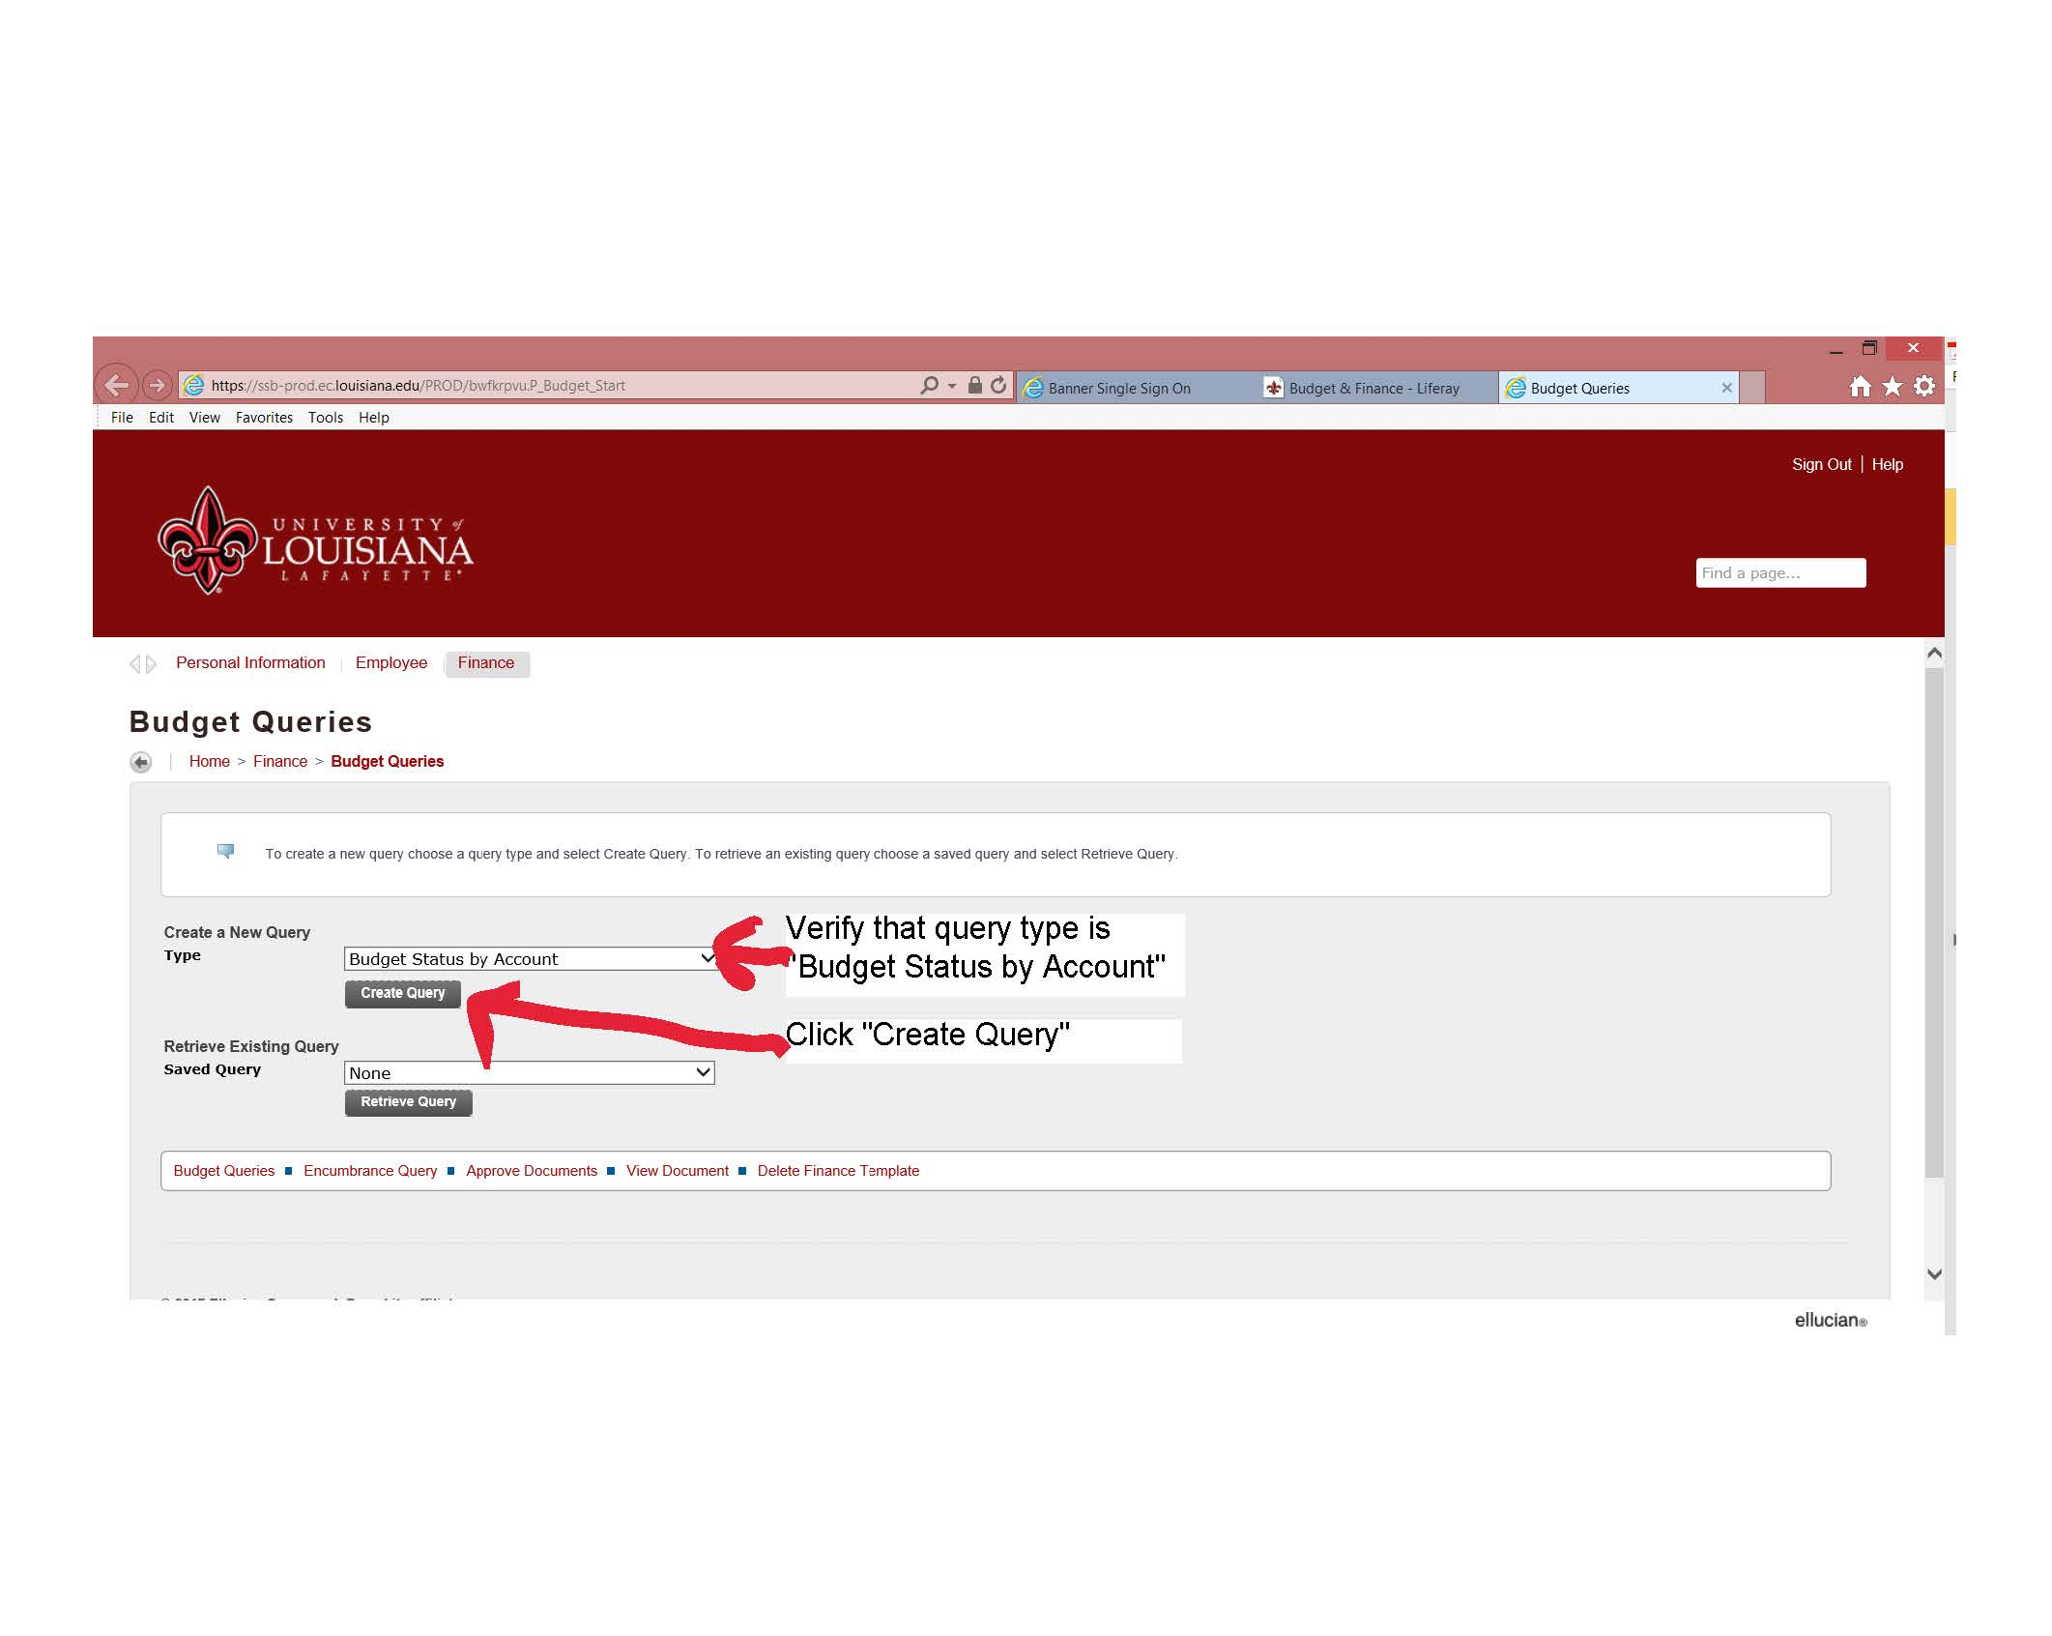

Step 4 – Select the columns you wish your search to have. To view encumbrances you will need to select (at minimum) the following: Year to Date, Encumbrances, Reservations, and Commitments. We recommend that Available Balance is also selected.
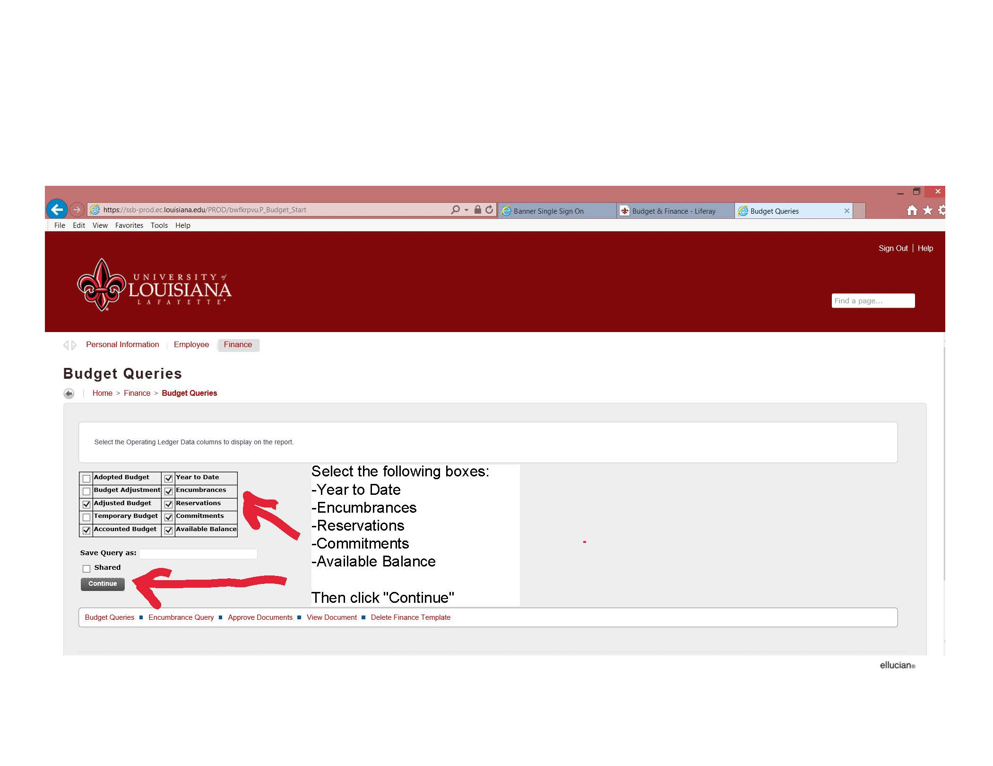
Step 5 – Enter FOAPAL detail. The “Chart of Accounts” will ALWAYS be 1. The query detail will retain the information from the last selection you made. Verify that the Fund and Organization are correct. You may need to remove information for a broader query (ex: remove the Account number from a prior query to view all accounts under that Fund/Org.)
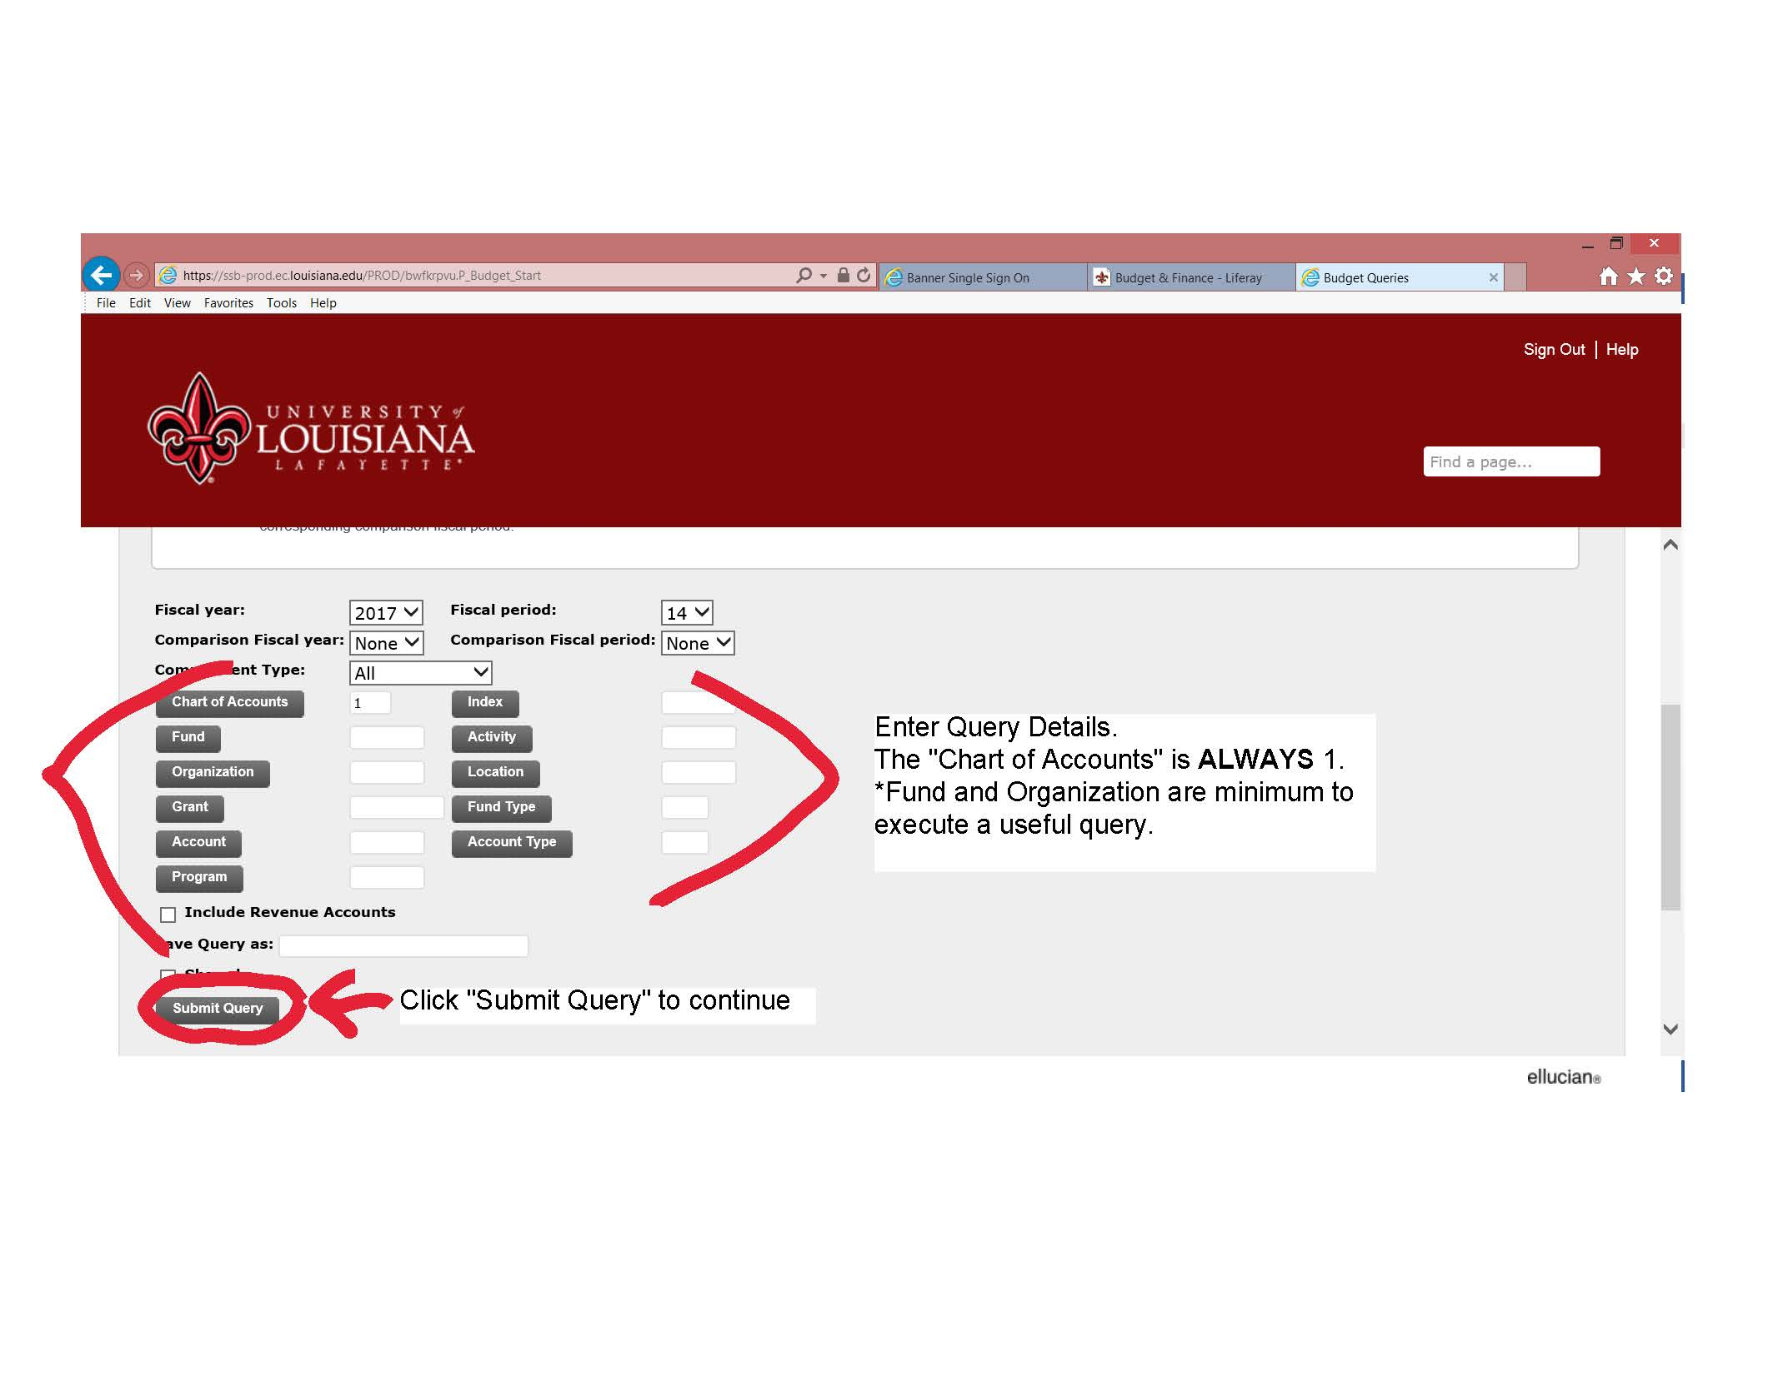
Step 6 – View and drill into the query results. Select each Encumbrance and Reservation that is RED to view documents. Verify that the listed documents are correct and should still be open.
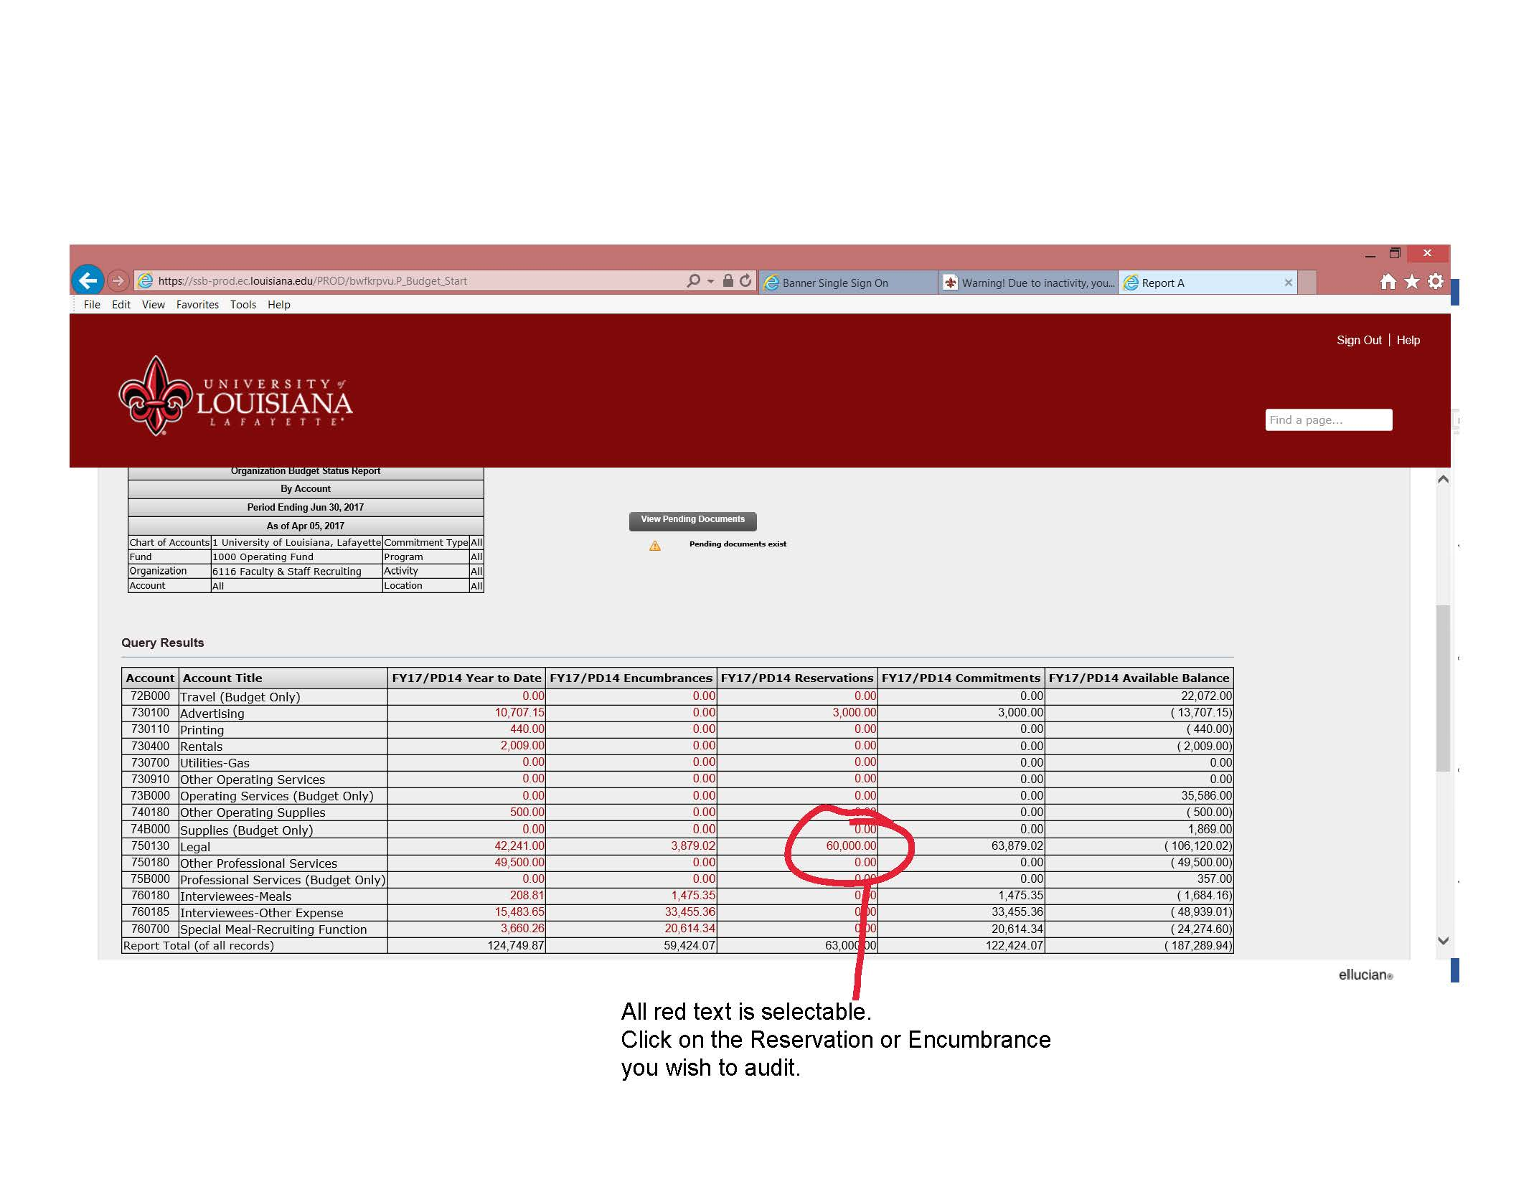
Step 7 – To close requisitions and/or purchase orders complete the Purchase Order Change Form and submit to Purchasing as soon as possible. To close travel, special meal or invited guests encumbrances, email Kassie Clark at kxs2315@louisiana.edu and provide the encumbrance number/Travel Request Number and the amount that needs to be cleared/cancelled. All Reimbursements must be submitted to Purchasing within 30 days following travel.

